Cause Title: GANAPATI (DEAD) BY HIS LRS VERSUS PRABHAKAR & OTHERS
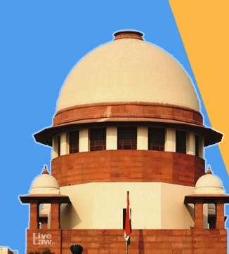
Hindu Succession Act |Widow's Limited Interest Becomes Absolute Under S14(1) Even Without Partition: Supreme Court

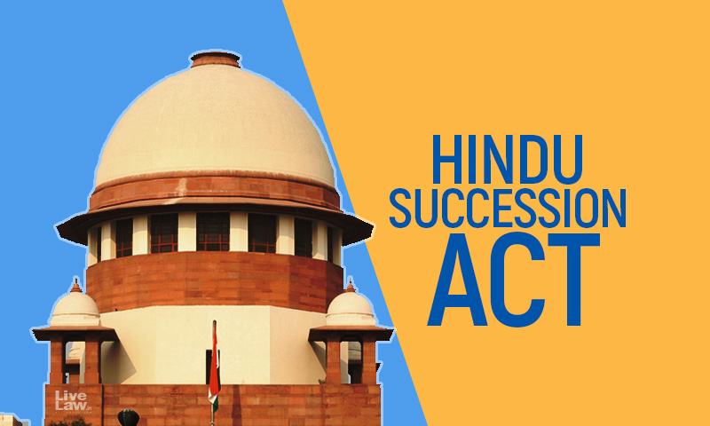
The Supreme Court has held that a Hindu widow who acquired an interest in her deceased husband's property under the Hindu Women's Rights to Property Act, 1937, could become the absolute owner of that interest by virtue of Section 14(1) of the Hindu Succession Act, 1956, even if no partition had taken place.
The Court observed that even where the property remains undivided, a widow's limited right in the property inherited upon her husband's death before 1956 is not extinguished merely because she did not seek or obtain a formal partition.
As per the Hindu Women's Rights to Property Act, 1937 (“1937 Act”), property devolved upon a widow upon her husband's death vests in her a limited right in the inherited property with a right to seek a partition but without a right of ownership. Upon the enactment of the Hindu Succession Act, 1956 (“1956 Act”), Section 14(1) grants absolute ownership rights to the widow over the property inherited by her, before or after the enactment, and regardless of whether partition took place at the instance of the widow
A bench of Justice SVN Bhatti and Justice NV Anjaria heard the case where the plaintiff-appellants sought to challenge the Karnataka High Court's Dharwad Bench decision which, while setting aside the concurrent findings of the trial court and First Appellate Court, had recognized the absolute ownership rights of the widow (represented by Respondents) in the property inherited by her in her husband's property after he died in 1949, i.e., before the enactment of the Hindu Succession Act.
The Trial Court and First Appellate Court denied the absolute ownership to the widow because she failed to seek partition of the inherited property under the 1937 Act, which, in a second appeal, was reversed by the High Court recognizing the absolute ownership right of the widow, regardless of the partition sought by the widow.
Aggrieved by the High Court's decision, the plaintiff, who was a son through the first wife of the widow's husband, through his legal representatives, approached the Supreme Court.
Affirming the High Court's judgment, the judgment authored by Justice Bhatti, referring to Section 14(1) of the 1956 Act, held that the property inherited by the widow became her absolute property, thereby removing the restrictive character associated with the property under the 1937 Act.
“…a Hindu widow, stepping into her husband's shoes, holds the properties by satisfying the requirement of Section 14(1) of the Act, 1956. Even assuming the Defendants (LRs of Widow) have failed to prove the factum of the oral partition pleaded by them, the necessary corollary in law under the Act, 1937, read with Section 14(1) of the Act, 1956, remains intact and unaffected.”, the Court observed.

Partition Of Property Acquired By Widow Before 1956 Act Not Essential For Claiming Absolute Ownership
The Court held that the absence of a formal partition between the widow and the surviving coparcener does not, by itself, prevent her limited interest from being enlarged into an absolute right under Section 14(1).
“The partition between the Plaintiff and Kashibai (widow), as is well settled, is not a sine qua non for continuing to enjoy the right as an independent or absolute owner of the property left behind by the prepositus. Even assuming, without deciding the said argument, that a partition has not occurred in the undivided property, the shares in the coparcenary are subject to fluctuation but not to denial of a right.”, the Court said.
The Court also relied on its earlier decisions in V. Tulasamma v. Sesha Reddy (1977) and Raghubar Singh v. Gulab Singh (1998), which recognise the broad operation of Section 14(1) in enlarging a Hindu woman's limited interest into an absolute one where that interest is traceable to a pre-existing right.
As a result, the appeal was dismissed.
Blog By Sarika Verma
Mediator (Supreme Court of India)
Panel Counsel (Union of India)

