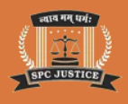

NALSAR Row full controversy
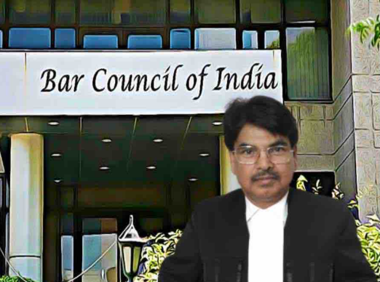
The NALSAR row in August 2026 was a major controversy in Indian legal education, sparked by students opposing Chief Justice of India (CJI) Surya Kant’s presence at their convocation. It escalated when the Bar Council of India (BCI) froze enrolment of the entire graduating batch, leading to Supreme Court intervention, widespread protests, and eventually an apology from BCI Chairperson Manan Kumar Mishra.

📌 Timeline of the NALSAR Controversy
Date | Event | Key Details
May–July 2026 | CJI Surya Kant’s remarks | Compared certain youth to “cockroaches” (later clarified as fake degree holders) and refused to view video evidence of alleged police brutality at Delhi’s Jantar Mantar protest. These remarks triggered student anger.
July 23, 2026 | Student representation | 70 NALSAR graduating students wrote to the administration opposing CJI as convocation chief guest, citing his dismissive stance on police excesses.
Early August 2026 | Leak to media | The internal letter was leaked, sparking national debate on dissent in legal education.
August 13, 2026 | BCI punitive order | BCI Chairperson Mishra directed state bar councils to halt enrolment of NALSAR’s 2026 batch and demanded names of students behind the protest.
Same day | Backlash & reversal | Massive online outrage, criticism from NLSIU Bengaluru students, and legal experts forced BCI to withdraw the order within hours.
August 14–15, 2026 | Supreme Court intervention | CJI Surya Kant clarified students had the right to peaceful protest and rebuked BCI for overreach.
August 15, 2026 | Mishra’s apology | On Independence Day, Mishra issued a public apology to law students, acknowledging hurt sentiments and affirming respect for dissent.
⚖️ Core Issues Raised
- Right to Dissent: Students argued that protesting against the CJI’s presence was consistent with constitutional values.
- BCI’s Authority: Critics noted BCI has no jurisdiction over students before enrolment under the Advocates Act, 1961.
- Judicial Reverence vs. Accountability: The row highlighted tension between traditional deference to judges and students’ demand for accountability.
🔥 Reactions
- Students: NALSAR and NLSIU students demanded a public apology, which was eventually delivered.
- Legal Fraternity: Many lawyers condemned BCI’s initial order as “abuse of power.”
- Bar Associations: Bombay Bar Association criticized Mishra’s apology as belated; BCI Co-Chair YR Sadashiva Reddy even demanded his resignation

The NALSAR row was not just about one convocation—it became a national debate on dissent, regulatory overreach, and the future of legal education in India. Mishra’s apology closed one chapter, but the controversy exposed deep cracks in how authority and student rights are balanced in India’s legal system.

BCI Chairperson Manan Kumar Mishra Apologises To Law Students Amid NALSAR Row
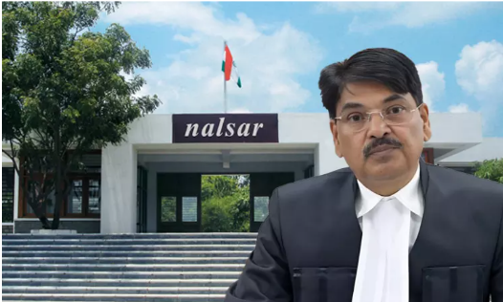
Bar Council of India (BCI) Chairperson Manan Kumar Mishra has formally apologised to law students after the NALSAR convocation controversy, acknowledging that his earlier actions and remarks may have hurt students’ sentiments. His apology came following Supreme Court intervention, which upheld students’ right to peaceful protest and halted punitive measures against NALSAR’s 2026 graduating batch.
🔑 Key Highlights of the Apology
- Issued on Independence Day (15 August 2026): Mishra addressed law students as “my dear young friends” and expressed regret for any anguish caused.
- Acknowledgment of Student Concerns: He stated, “If anything connected with the present controversy, any of my words, or letter, has hurt the feelings of our law students, I sincerely regret and apologise for the same.”
- Not About Ego or Prestige: Mishra clarified that apologising was about respecting students’ concerns, not protecting personal pride.
- Support for Peaceful Dissent: He affirmed that disagreement and protest are integral to constitutional democracy and that students should be free to form their own opinions.
⚖️ Background of the NALSAR Row
- Trigger: Students at NALSAR opposed Chief Justice of India (CJI) Surya Kant being invited as chief guest at their convocation, citing his remarks during earlier student protests and police action in Delhi.
- BCI’s Initial Action: On 13 August 2026, Mishra directed state bar councils to halt enrolment of NALSAR’s entire graduating batch.
- Backlash: The move was condemned by students, alumni, and legal bodies, including NLSIU Bengaluru. Within hours, BCI reversed the order.
- Supreme Court Intervention: CJI Surya Kant himself clarified that students had the right to protest peacefully and barred punitive action against them.
📌 Reactions to the Apology
- Students’ Demands: NALSAR’s Student Bar Council and NLSIU students had explicitly demanded a public apology, which Mishra eventually issued.
- Legal Fraternity Response: While some welcomed the apology, others, including the Bombay Bar Association, criticized it as “belated” and an “abuse of power” for initially condemning students unheard.
- Calls for Resignation: BCI Co-Chair YR Sadashiva Reddy demanded Mishra’s resignation, citing misuse of funds and the NALSAR episode as reasons, though Mishra has refused to step down.
📝 Key Takeaway
This episode underscores the tension between regulatory authority and student rights in India’s legal education system. Mishra’s apology is a significant acknowledgment of the importance of dissent in a constitutional democracy, but criticism from bar associations and colleagues suggests that the controversy may continue to impact his leadership at the BCI.

