Cost Of Convenience: UPI, MDR And India’s Digital Future
A Legal-Policy Brief

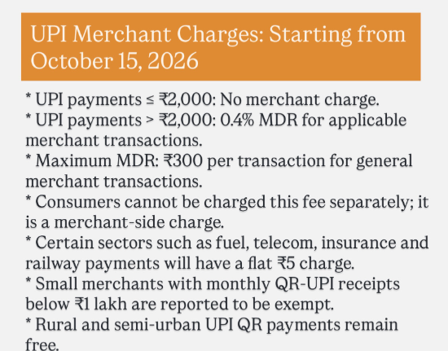
By Sarika Verma
Mediator, Supreme Court of India | Panel Advocate, Union of India

India’s Unified Payments Interface (UPI) has fundamentally transformed the manner in which individuals, businesses and institutions conduct financial transactions. What began in 2016 as an initiative to facilitate seamless digital payments has evolved into a critical component of India’s digital public infrastructure.

As UPI enters its second decade, the debate surrounding the Merchant Discount Rate (MDR) raises an important policy question: how can India preserve the accessibility and convenience of digital payments while ensuring that the infrastructure supporting them remains financially and technologically sustainable?

The Zero-MDR Model

The zero-MDR framework played an important role in encouraging merchants and consumers to adopt digital payments. By eliminating transaction costs for merchants, the policy helped make UPI particularly attractive to small businesses, retailers and consumers.

However, a system that provides transactions without a merchant-side processing charge still involves substantial expenditure on technology, cybersecurity, fraud prevention, payment infrastructure and system maintenance.

The issue, therefore, is not simply whether digital payments should remain inexpensive, but who should bear the underlying cost of maintaining the system.

The Emerging MDR Debate

MDR represents a mechanism through which payment-processing costs can be shared with participating merchants. A carefully structured MDR framework could provide an additional source of revenue for strengthening payment infrastructure while preserving the consumer-facing convenience of UPI.

Any such framework, however, must be designed with proportionality and inclusivity in mind. Small merchants and low-value transactions should not face a disproportionate financial burden. Appropriate thresholds, exemptions and safeguards can help ensure that the digital-payment ecosystem remains accessible to India's smallest businesses.

Consumer Protection

The preservation of free or low-cost consumer transactions is an important consideration. At the same time, regulatory mechanisms should guard against the possibility of transaction-related costs being indirectly transferred to consumers through increased prices.

Transparency is therefore essential. Merchants, payment-service providers and consumers should have clarity regarding the nature and incidence of any applicable charges.

Fiscal Sustainability

The increasing scale of UPI also presents a question of public-finance policy. Government support can be justified when it advances financial inclusion and digitalisation, but the long-term expansion of a major payment infrastructure inevitably raises questions about sustainable financing.

A transition from predominantly subsidy-supported infrastructure toward a shared-cost model may therefore warrant consideration, provided that the transition does not undermine financial inclusion or discourage participation by small merchants.

Cybersecurity and System Resilience

Digital payments are increasingly dependent upon reliable technological infrastructure. Investment in cybersecurity, fraud detection, data protection and system resilience is consequently not merely a commercial concern; it is an important component of public trust in digital financial systems.

A sustainable revenue mechanism could potentially provide greater resources for these functions, particularly as transaction volumes and technological risks continue to evolve.

A Balanced Regulatory Approach

The MDR debate should ultimately be considered within the broader objectives of India's digital economy:

Consumer accessibility should remain protected.
Small merchants should receive appropriate safeguards.
Payment infrastructure should have sustainable sources of funding.
Cybersecurity and fraud prevention should receive continuing investment.
Government subsidies should be evaluated periodically for effectiveness and fiscal sustainability.
Regulatory transparency should ensure that the distribution of costs is clearly understood by all participants.
Conclusion

UPI's success demonstrates the transformative potential of India's digital public infrastructure. The next phase of its development requires attention not only to adoption but also to long-term sustainability, security and equitable cost distribution.

The MDR discussion should therefore be approached as part of a larger policy conversation about the future financing of India's digital-payment ecosystem. The objective should be to maintain the ease and inclusivity that made UPI successful while ensuring that the infrastructure behind that convenience remains robust, secure and financially sustainable.

— Sarika Verma
Mediator, Supreme Court of India
Panel Advocate, Union of India

